Apple – Energy Story

**Did you know that the food you eat is the fuel your liver needs to keep you alive?**

When you eat an apple it goes down to your stomach where it is now **apple sauce**. It travels on to your small intestine where the tiny blood vessels in its wall pick up the apple sauce and **carry it over to your liver** where zillions of liver cells, like Santa Claus’s helpers, are waiting to **do their life sustaining jobs**.

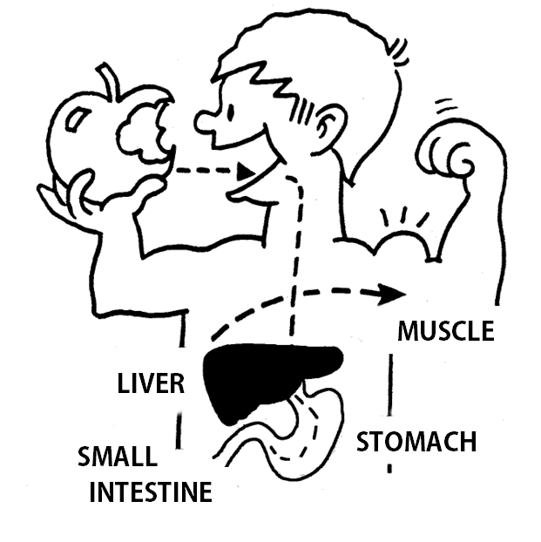These hard working **liver cells turn the apple sauce into energy, muscles and bones** so you can be a ballet dancer or football player. They make immune factors that **keep you from catching all the germs** and viruses that surround you, and **help you get well** when you are sick. They even make a sticky stuff like glue that **stops cuts from bleeding** from the inside.

Your **liver is your internal chemical factory**, guardian, energy source and life preserver. It is up to you to **feed it the right kind of food** so it can keep you alive, healthy and functioning 24/7.

If you consume lots of **fatty foods and sugary drinks**, or misuse and **abuse drugs or alcohol** . . . the same thing happens. They go down to your stomach and over to your liver where they can **severely damage your Santa’s Helpers (liver cells)**.

If you keep feeding your liver **drugs, alcohol and unhealthy food**, you won’t have enough healthy liver cells left to do their job and **your liver will shut down**. When your liver shuts down . . . so do you.

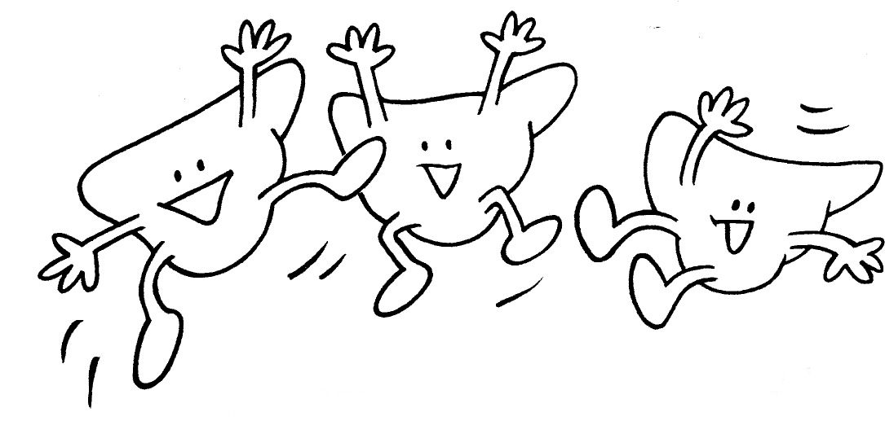Your liver can’t talk. It is **up to you to avoid drugs and alcohol**. Eat lots of fruits and veggies, chicken and go easy on the pizzas, sodas and candy. They **can hurt your liver cells and make you sick**.

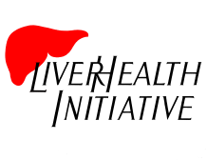**Take good care of your liver and it will take good care of you.**

301.625.9076 – liver-heath.org ©